# Steps to set up Glass Development environment in Windows:

## Download and install the Java Development Kit (JDK).

Download file from the below link: <http://www.oracle.com/technetwork/java/javase/downloads/jdk8-downloads-2133151.html>

From the given list, select the required .exe file specified for Windows based on the number of bits of your system (32 bit or 64 bit). Follow the instructions to install the JDK, and make note of the file location where the JDK is being installed.

Once the installation is completed, the JDK path needs to be setup in the system environment variables. The steps are as follows:

* 1. Open the properties of "**My Computer**" by either right-clicking the icon on the desktop or right-clicking **Start > My Computer**. When the pop up menu opens, scroll to the bottom and select "**Properties**".
  2. This should open a window named "**System Properties**". Click on the "**Advanced**" tab.
  3. Click "**Environment Variables**".
  4. In the window that follows double-click on the "**Path**" variable on either of the option boxes. It is recommended to edit the variable in the box "**User variables for (your username)**".
  5. Once the variable is opened, a text box in yet another window appears. Careful not to delete anything in this box. At the end of the text box, add a semi-colon if there is not one already, and add the file path up to the **bin** folder of your **JDK directory** (say "C:\Program Files\Java\jdk1.7.0\bin") to the text box. This is assuming you did not change the file path of the installation.
  6. **Click "Apply" and "OK" to all the windows you have just opened.**  To check if the setup was successful, open the command prompt and type **java –version** , this should show you a result with your JDK version as follows:

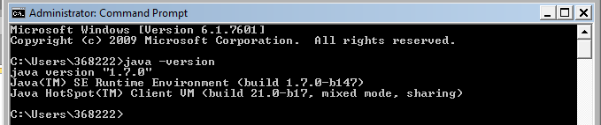

## Android SDK setup

Next is the Android SDK setup. You can download the adt bundle (which includes the Android SDK and eclipse) from here:

<http://developer.android.com/sdk/index.html>

To install the ADT, click on the **Download Eclipse ADT with the Android SDK for Windows** button and follow the instructions (select the number of bits from the radio button provided based on your system)

Once the ADT zip file is downloaded, extract it to any folder. The folder will contain the following contents:

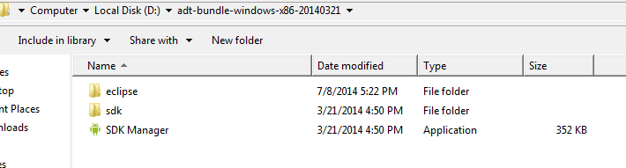

## Glass Development Kit(GDK) setup

Once the ADT is setup, we move on to the Glass Development Kit (GDK) setup. For, this from the shown above open SDK Manager and run the same.

A window will open:

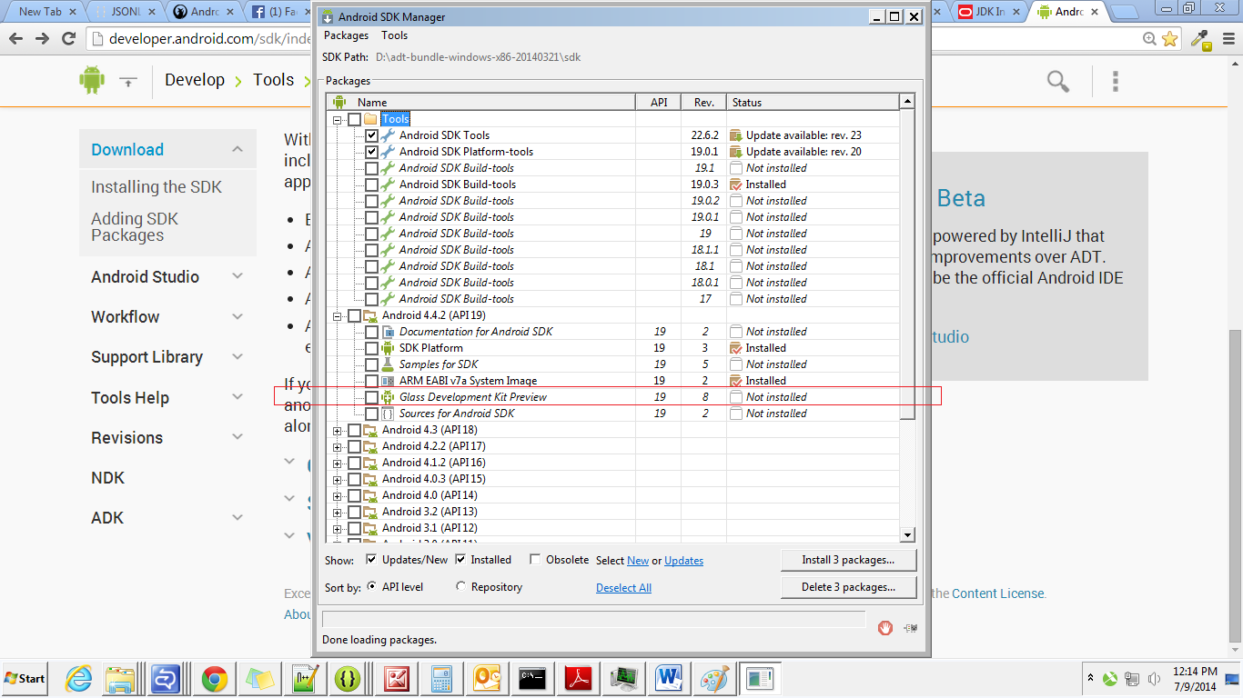

In that window, under Android 4.4.2(API 19), select Glass Development Kit Preview and install the same. On successful install, close the SDK and close the Eclipse (if open).

# Steps to install and uninstall APK in Google Glass:

Please follow the steps as per the screenshots shown below:

**Step 1:**

Download the apk attached in mail.

**Step 2:**

Connect your glass to your laptop. Ensure debug mode is on in your glass.

To enable debug mode in glass, go to settings ->Device info and tap. Here you will find the option “Turn on debug” and select it by tap. Now debug mode is on in your glass.

Now we need to check whether adb is detecting your connected device,

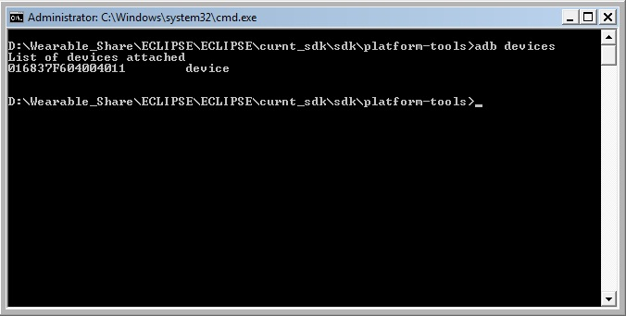

It should list the attached device, or you need to check whether you have admin rights or any driver need to be installed in your machine to detect the glass.

**Step 3:**

Install apk into glass,

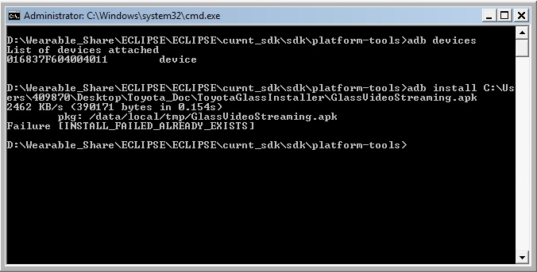

Here it was failure because it was already installed. Or it will show success message.

**Step 4:**

To uninstall the application type the following command,

**Windows:**

Navigate to platform-tools in command prompt and type

*adb uninstall packagename*

**MAC:**

Navigate to platform-tools in terminal and type

*./adb uninstall packagename*